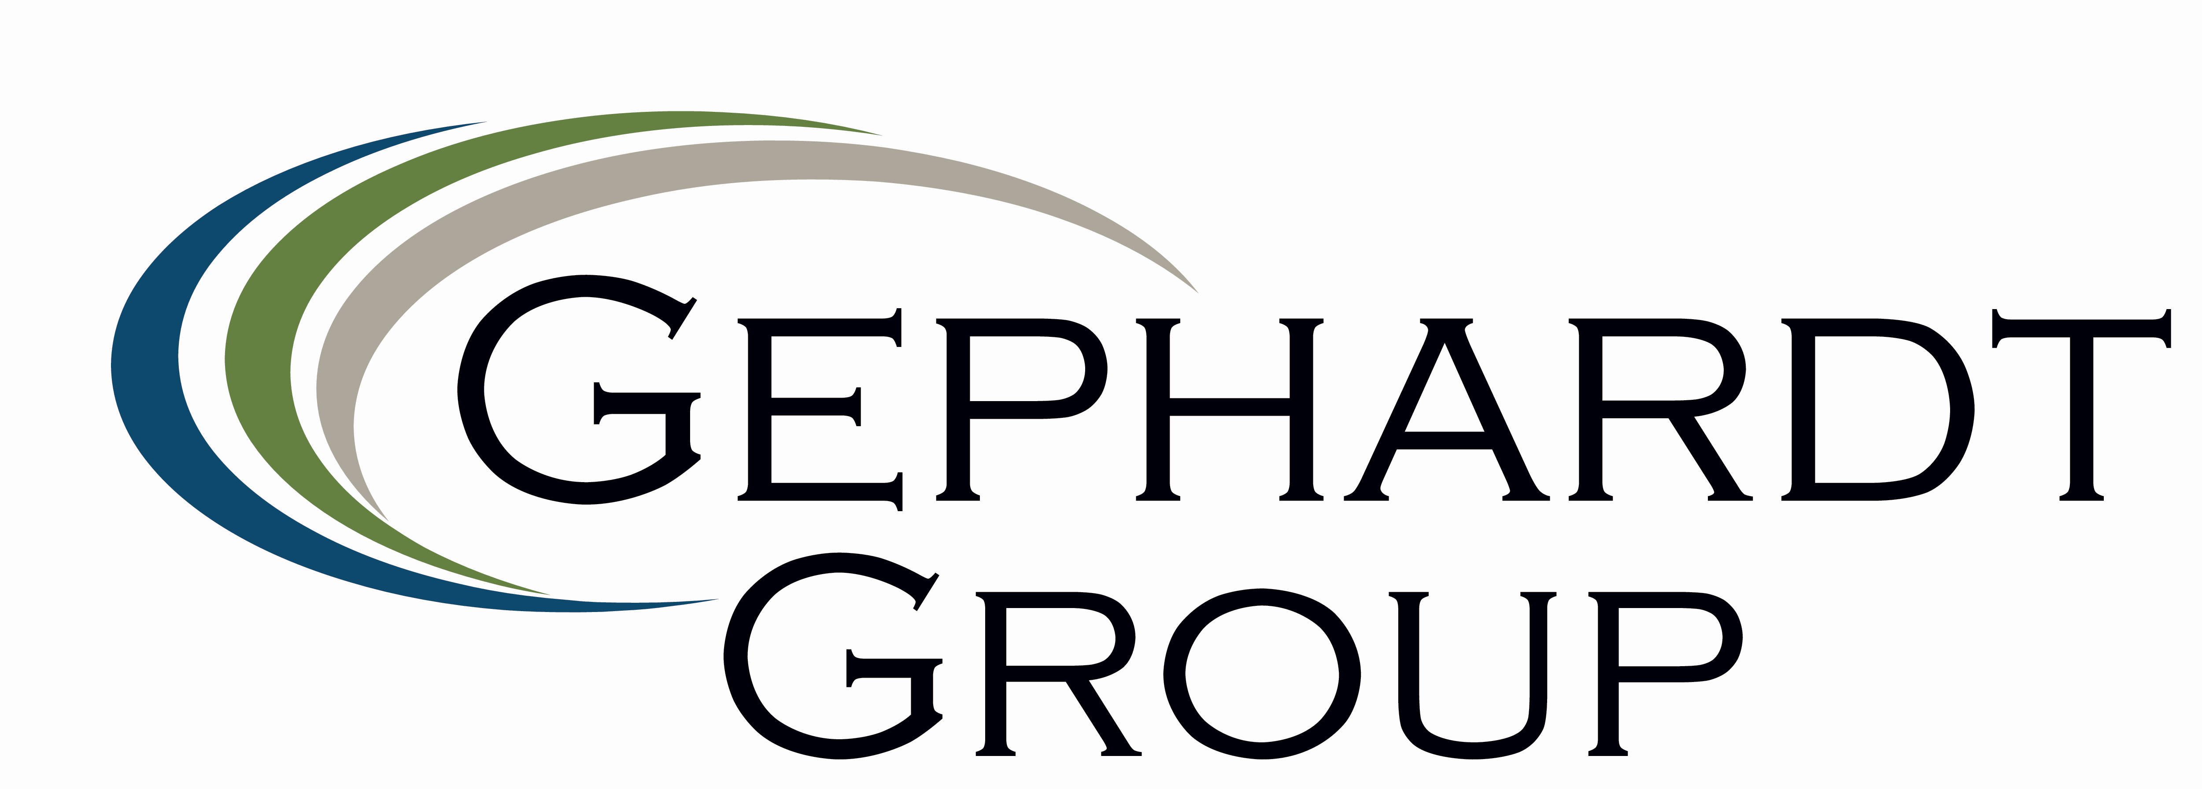

GEPHARDT LABOR ADVISORY
HELPS RESOLVE LAS VEGAS DISPUTE

In 2008, Freeman, the leading provider of integrated services for trade shows, conventions, and meetings in U.S., made the decision to construct a new office and warehouse complex in order to consolidate operations in its largest market, Las Vegas. However, during the construction process, a dispute with the IBEW local union threatened to unsettle the project and negatively affect a long standing business relationship. After six months of unsatisfactory negotiations, Freeman called on Gephardt Group to facilitate discussions and seek a resolution that would satisfy all parties.

Within three weeks, Gephardt Group’s mediation work with Freeman and the local IBEW leadership, as well as IBEW President Ed Hill and Executive Assistant Liz Shuler, resulted in a solution that not only kept the project on track for completion but also worked to strengthen the relationship between all parties.

“Gephardt Group was able to take a difficult and sensitive situation and bring creative ideas that worked for all of us,” said Hill. “We trust Congressman Gephardt and his team for their labor relations expertise and objectivity.”

According to John F. O’Connell, Jr., President of Freeman, Gephardt Group’s “guidance, counsel and candidness were key drivers in finding a successful resolution that worked for both parties.”

Gephardt Group Labor Advisory Services specializes in labor-related services such as collective bargaining support, labor cost restructuring, mediation, and employee relations consulting.

www.gephardtgroup.com

